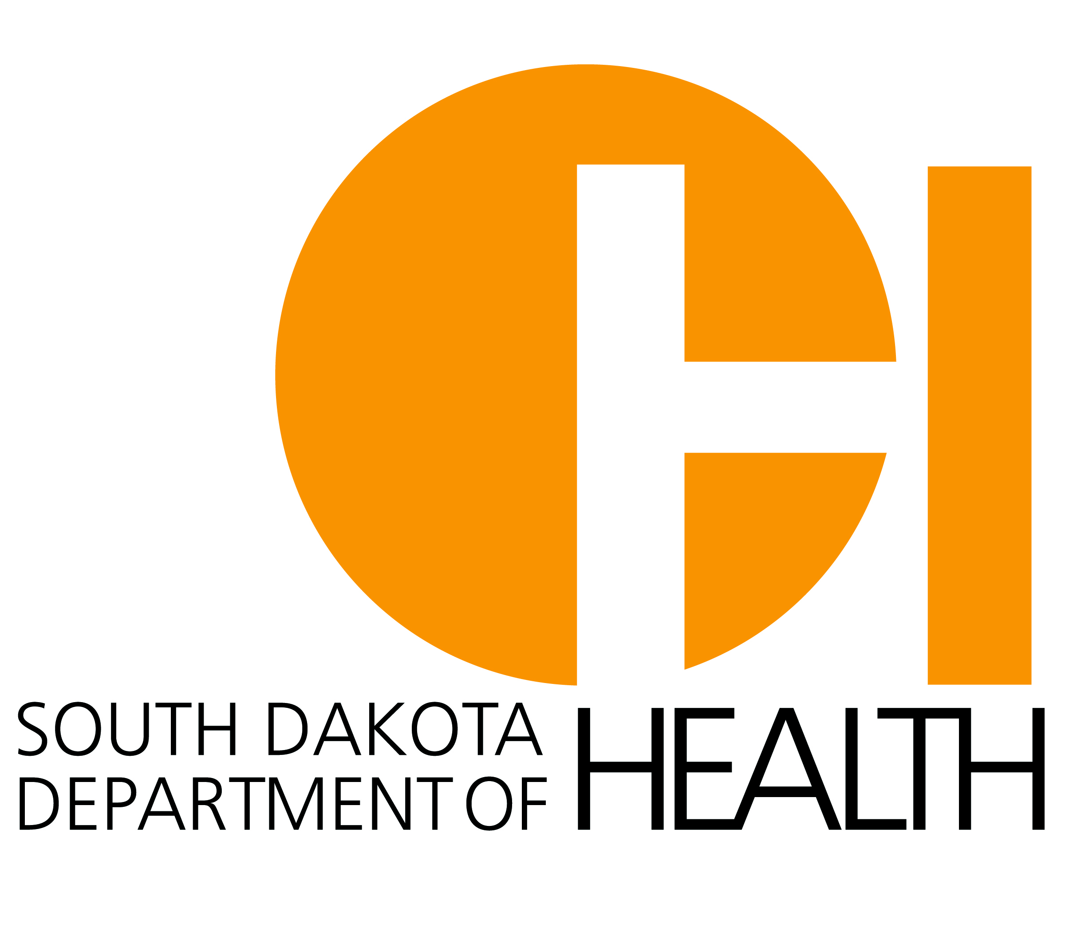

South Dakota Department of Health (SD DOH)
South Dakota Comprehensive Cancer Control Program and WorkWell Partnership Request for Applications #19CP0002
Worksite UV Protection Policy for Outdoor Workers

Skin cancer is the most common and most preventable form of cancer in the United States. Adults spend more than one-third of their day at the workplace and workers who spend a majority of that workday outdoors are at increased risk for skin cancer. Outdoor workers’ risk is exacerbated as a result of the nature of their occupation and over exposure to UV radiation, the primary cause of skin cancer.

Purpose: The SD DOH will assist worksites interested in implementing a worksite UV protection policy and evidence-based sun safety interventions to reduce the burden of skin cancer. Projects will be guided by the Sun-Safe Worksite Guide, which offers ideas and suggestions for creating a sun safe worksite through sun safety practices and policies.

Eligibility Criteria: All SD worksites whose employee base includes outdoor workers are eligible to apply for funding. Examples of worksites with outdoor workers include, but are not limited to, parks and recreation, public works, city departments, construction, etc.

Award: Applicants may request up to $1,000, with up to three applicants funded.

Funding Parameters: Funding will be awarded for projects that strategically address policy, system, and environment change related to the promotion of UV protection practices. Worksites are required to develop a Worksite UV Protection Policy and implement sun safety strategies that support the policy. Strategies should be designed to create policy, system, and environment changes and provide opportunities not already offered to employees related to UV protection. Health-related policies are formal or informal written statements that are designed to protect or promote employee health. Environmental change refers to the physical factors at and near the workplace that help protect employee health and safety, e.g. shade structures. System change refers to modifications made to the rules within an organization, e.g. ongoing worksite sun safety education.

Policy Development: The SD DOH has developed a Worksite UV Protection Model Policy to guide policy development and adoption in the workplace for UV protection. The model policy document is available as a free download using the following link: http://goodandhealthysd.org/workplaces/policies/. Worksites applying for funding will use this document as a guide for developing a UV protection policy for their workplace.

Sun Safety Strategies: Worksites are required to implement evidence-based strategies that support the Worksite UV Protection Policy. Examples of strategies including the following:
- Environmental approaches to encourage sun protection (e.g. provide sunscreen, lip balm, wide-brimmed hats, shade supports such as umbrellas and tents) to employees.
- Educational approaches (e.g. providing informational messages about sun protection to workers through instruction, small media such as posters or brochures, or both)
- Activities designed to influence knowledge, attitudes, or behavior of workers (e.g., employee/supervisor role modeling or demonstrating behaviors)
- Offer flextime for employees to avoid prime UV time, 10a.m. – 2p.m. (allowing employees to shift their work schedules, such as coming in earlier or later or taking a lunch break at alternate times)

Timeline:
RFA Schedule | Date
Request for grant applications released and posted to http://www.cancersd.com/ | March 21, 2018
Last day for questions and to request review of grant application  Please direct questions to: lexi.pugsley@state.sd.us | April 24, 2018
Application submission deadline | 5:00pm CT on April 25, 2018
Notice of grant award issued (via email) | Week of May 14th (tentative)
Project Period | 6/1/2018 - 9/30/2018

Grantee Will:
- Participate in webinar and in-person trainings.
- Attend the annual WorkWell Summit in Mitchell on October 4, 2018.
- Participate in technical assistance calls with SD DOH.
- Develop and implement a Worksite UV Protection Policy by July 31, 2018.
- Submit one progress report. (Due 9/30/18)
- Submit one success story. (template will be provided)
- Have the project lead complete a pre/post evaluation assessment.

Department of Health Will:
- Provide training webinar and in-person training on sun safety policy, systems, and environmental enhancements to support a healthy worksite.
- Provide resources and ongoing technical assistance for implementation of a workplace UV protection policy.
- Conduct one on-site visit to worksite.
- Provide funding to support project implementation upon completion of a W-9 and grant agreement.

Funds CANNOT be used for:
- Lobbying efforts at the local, state, or federal level, purchasing food or beverages, purchasing equipment, construction, infrastructure or building maintenance, indirect costs, or staff time.

Funds CAN be used for items such as:
- Bulk sunscreen, dispenser rack, smaller bottles to transport sunscreen for reapplication, wide-brimmed hats, UV lip protector, umbrellas and temporary shade, and printing expenses.

Proposal Content (Maximum 4 pages per application)
- Section 1. Worksite Information. Provide worksite information and current sun safety practices.
- Section 2. Project Plan: Review the Worksite UV Protection Model Policy (http://goodandhealthysd.org/workplaces/policies/) for a list of guidelines that you can adopt or modify and include into your worksite UV protection policy. Worksites can adopt some or all of the guidelines from the policy. Use these guidelines to complete the draft project plan below. A Worksite UV Protection Policy must be developed and adopted by the worksite by July 31, 2018. South Dakota Comprehensive Cancer Control Program project leads will work with funded worksites to refine their Project Plan to develop a comprehensive plan for development, implementation, and evaluation of the policy.
- Section 3. Budget. Complete a proposed project budget. Applicants can budget for registration fees to attend the WorkWell Summit.

Appendices
- Appendix A. Project Checklist: This provides an outline of the steps involved with developing and implementing a Worksite UV Protection Policy for a worksite.
- Appendix B. Budget Example: Refer to for assistance with development of the proposed project budget.
- Appendix C. Project Timeline: This provides information on when the steps included in the Project Checklist will be implemented.
- Appendix D. Sun Safety Guidelines and Sample Activities: List of policy guidelines and sample activities that you can adopt or modify and include into your policy.

GRANT APPLICATION VIA ELECTRONIC SUBMISSION TO lexi.pugsley@state.sd.us
DUE NO LATER THAN 5:00 PM CENTRAL TIME ON April 25, 2018

-----END OF INSTRUCTIONS. APPLICATION BEGINS ON NEXT PAGE.-----

Application: Worksite UV Protection Policy for Outdoor Workers

Section 1. Worksite Information

Worksite Name: ____________________________________________________________________________________

Address: __________________________________________________________________________________________

Demographics:
Worksite Description (Type of Business): ___Parks and Recreation ____Public Works ____ City Department

___Construction _____Farm ____Other (please explain)_________________________________________________

Worksite Size (total employees): ______ Full-time ________Part-time _______ Seasonal

_______# of employees who spend 20% or more of a typical workday outside

*If you have a business with multiple locations throughout the state, only include the number of employees that work at the location(s) that will be implementing the policy. (i.e. Smith Enterprises has 15 locations across the state. The Mitchell location plans to apply for the grant. Only include the number of employees at the Mitchell location.)

Primary Project Contact Information:

Name: __________________________________________ Phone: ____________________________

E-mail: _____________________________________________________________________________________

Mailing Address: ____________________________________________________________________________
- Current Worksite Wellness Committee in place? Yes ☐ No ☐
If no – is there a team of at least 2 individuals willing to complete the objectives outlined for project completion? Yes ☐ No ☐

- Do you currently have a UV protection policy in place at your worksite?
☐ Yes (If Yes, please attach)
☐ No
☐ Other (please list :__________________________________)

- Are you currently promoting any of the following UV protection strategies to employees in your worksite (select all that apply)?
☐ We are not doing any UV protection efforts

Environment
☐ Provide temporary and permanent shade structures wherever possible for outdoor workers (e.g. umbrellas
on construction equipment or picnic tables in outdoor lunch areas; umbrellas, tents, and other portable
shade devices for offsite outdoor workers).
☐ Flextime to avoid prime UV time, 10a.m. – 2p.m. (allowing employees to shift their work schedules, such as
coming in earlier or later or taking a lunch break at alternate times)

Work Safety
☐ Provision of personal sun protective clothing and equipment
☐ Full-brimmed hat ☐ Long-sleeved shirt ☐ Full-length pants ☐ Sunglasses
☐ Provide an annual allowance to workers for the purchase sun safety clothing and protective
equipment.
☐ Provision of sunscreen and lip balm (SPF 30+)

Health Behaviors
☐ Encourage employees to use shaded areas.
☐ Encourage or require outdoor workers to wear wide-brimmed, sun safe hats.
☐ Encourage or require outdoor workers to wear long-sleeved shirts with collars and long pants, and
discourage sleeveless shirts, tank tops, and shorts.
☐ Encourage employees to wear sunglasses or goggles that filter out 99-100 percent of UVA and UVB rays.
☐ Encourage supervisors to set a good example by wearing sun-protective clothes and sunscreen.

Education & Awareness
☐ Encourage and train employees to become sun safety peer educators and role models for their coworkers.
☐ Teach employees about sun safety and reinforce policies through safety instruction.
☐ Offer annual health promotion programs and skin cancer screenings to all employees.
☐ Post the UV Index daily on bulletin boards and electronic mail services.
☐ Other________________________________________________________

Section 2. Project Plan
Please complete the project plan to fit your worksite by checking the box for each guideline your worksite plans to implement and adding associated activities in the spaces below. Sun safety guidelines can be adopted as needed to fit your worksite needs. If you choose to include more activities, please add additional content. There is no required number of guidelines that must be implemented; however, budget requests should be commensurate with the number of guidelines and activities proposed and the total number of individuals impacted.

Sun Safety Guidelines
☐ For all outdoor labor occurring on sunny days – especially between 10:00 a.m. to 4 p.m. – employees will be (encouraged, required) to:
A. Work in shaded areas, when practical.
B. Wear sun-protective clothing that includes:
(1) Four-inch or more full-brimmed hats that, when worn, create a shadow that completely covers the head, face, nose, ears, and neck.
(2) Long-sleeve shirts and full-length pants made of tightly woven fabric that is lightweight.
C. Wear sunglasses that protect from 100 percent of UVA & UVB (full spectrum).
D. Carry and use sunscreen and lip balm with a minimum of SPF 15.
Activity(s) | Person(s) Responsible | Partner(s) | Resources Needed
☐ (Organization) supervisors will assess personal protective equipment, including hats, to determine if and how they might be modified to better protect outdoor workers from over-exposure to UV rays.
Activity(s) | Person(s) Responsible | Partner(s) | Resources Needed
☐ (Organization) supervisors will provide employees personal sun protective equipment that includes sunscreen with an SPF of at least 15, SPF 15 lip balm, sunglasses, sun protective work clothing (long-sleeves and long pants), and sun protective hats.
Activity(s) | Person(s) Responsible | Partner(s) | Resources Needed
☐ (Organization) supervisors will provide annual sun safety training for all employees encouraging them to practice sun safety while on the job.
Activity(s) | Person(s) Responsible | Partner(s) | Resources Needed
☐ (Organization) administrative staff will provide annual sun safety training for supervisors to (encourage, require) role modeling and reinforce use of sun-protective equipment for employees.
Activity(s) | Person(s) Responsible | Partner(s) | Resources Needed
☐ (Organization) supervisors will post the EPA’s Ultra Violet (UV) Index daily for employees.
Activity(s) | Person(s) Responsible | Partner(s) | Resources Needed
☐ The Worksite UV Protection Policy guidelines will be communicated and reinforced to employees by supervisors and administrative staff through new employee orientation, verbal reminders, posters, signs, pamphlets, email notifications, payroll stuffers, newsletters, and meetings.
Activity(s) | Person(s) Responsible | Partner(s) | Resources Needed
☐ Enforcement of this policy is the shared responsibility of all (organization name) personnel. All employees are authorized and (encouraged, required) to communicate and partake in the necessary precautions of this policy during the working hours to prevent and reduce the risk of skin cancer.
Activity(s) | Person(s) Responsible | Partner(s) | Resources Needed
☐ (Organization) supervisors will understand, model and (encourage, require) employees to follow the Worksite UV Protection Policy guidelines.
Activity(s) | Person(s) Responsible | Partner(s) | Resources Needed
☐ Employees will be (encouraged, required) to report sun related injuries (sunburn, heatstroke, etc.) to an immediate supervisor.
Activity(s) | Person(s) Responsible | Partner(s) | Resources Needed
☐ (Organization) will provide shaded outdoor break areas for all employees.
Activity(s) | Person(s) Responsible | Partner(s) | Resources Needed
☐ As scheduling permits, (Organization) supervisors will schedule outdoor work before 10:00 a.m. or after 4:00 p.m. when feasible in April through September to avoid peak sun intensity. However, scheduling constraints should not reduce productivity.
Activity(s) | Person(s) Responsible | Partner(s) | Resources Needed
☐ (Organization) will provide permanent or temporary shade structures for off-site jobs whenever feasible.
Activity(s) | Person(s) Responsible | Partner(s) | Resources Needed
☐ (Organization) supervisors will annually evaluate and revise sun safety programs, policies, and procedures. Supervisors will implement sun safety programs all year, especially during, but not restricted to, the months of April through September. Evaluation of the effectiveness of the policy should be ongoing.
Activity(s) | Person(s) Responsible | Partner(s) | Resources Needed

Section 3. Budget

Budget
Item | Quantity | Cost per unit | Estimated Total Cost | Support or justification for policy, system or environmental change
Budget Total

-----END OF APPLICATION. APPENDICIES BEGIN BELOW.-----

Appendix A: Project Checklist
Step 1: Create a wellness team or committee or build the capacity of existing wellness team or committee.
- Select recognized leaders to champion the program and team members from all areas of the business.
- Have all team members read the Worksite UV Protection Model Policy and Sun-Safe Worksite Guide.
- Have project lead complete pre-assessment.

Step 2: Assess the worksite environment:
- Complete assessment: Assessing your worksite’s sun safety.

Step 3: Solicit input from employees and management.
- Solicit input from employees and management regarding sun safety knowledge and practices, as well as barriers to adhering sun safe practices, to assist with developing an effective UV Policy.

Step 4: Finalize the project plan with objectives, strategies and a projected timeline.

Step 5: Tailor Worksite UV Protection Model Policy to align with language and formatting applicable to your worksite.
- Begin communication through appropriate administrative channels to approve policy.
- Utilize worksite assessment and input from employees to develop

Step 6: Obtain final approval of policy
  - Add to policy manual
- Work with administration to make policy overview a part of all new employee training.

Step 7: Provide Worksite UV Protection
- Install bulk sunscreen stations, provide shaded outdoor environments for work, etc.

Step 8: Implementation
- Communicate the policy to worksite staff and employees: Include policy within worksite communication materials. (e.g. newsletters, posters in breakroom, letter to employees, e-mail list serve, etc.)
- Provide staff training on UV safety, new policy, and UV protection.
- Implement sun safety strategies.

Step 9: Project Evaluation
- Evaluate implementation of sun safety strategies.
- Have project lead complete post-assessment.

Step 10: Submit Progress Report (using the template provided) to the Department of Health by September 30, 2018.

Appendix B: Budget Example
Item | Quantity | Cost per unit | Estimated Total Cost | Support or justification for policy, system or environmental change
1 gallon 30 SPF Bulk Sunscreen | 1 | $120 | $120 | Support implementation of UV protection policy; encourage employees to wear UV protection
Wall Mount Bracket | 1 | $20 | $20 | Support implementation of UV protection policy; encourage employees to wear UV protection
15 SPF Lip Protector | 75 | $2 | $150 | Support implementation of UV protection policy; encourage employees to wear UV protection
Umbrella | 4 | $75 | $300 | Support implementation of UV protection policy; enhance built environment to encourage UV protection
Wide-brimmed hats | 25 | $10 | $250 | Support implementation of UV protection policy; encourage employees to wear UV protection
Refillable, portable sunscreen bottles | 75 | $1.50 | $112.50 | Support implementation of UV protection policy; enhance access to UV protection; encourage employees to wear UV protection
Budget Total |  |  |  | $952.50

Appendix C: Project Timeline
Project Timeline
Activity | June |  | July | Aug | Sept
Webinar: Project Overview, Skin Cancer 101 and Worksite Role in Skin Cancer Prevention
Step 1: Create a Wellness Team or build the capacity
Step 2: Assess Worksite Environment
Step 3: Solicit input from employees and management
Webinar: Worksite UV Protection Policy Development and Implementation
Site Visit: Worksite Committee will be provided in-person technical
assistance to develop project plan
Step 4: Finalize Project Plan for Policy
Step 5: Tailor Worksite UV Protection Model Policy
Step 6: Obtain final approval of policy
Step 7: Provide Worksite UV Protection
Step 8: Implementation: Communicate the Policy, implement sun safety strategies, educate employees
Step 9: Project Evaluation
Step 10: Submit Progress Report to DOH
Appendix D. Sun Safety Guidelines and Sample Activities
Personal Protective Equipment
For all outdoor labor occurring on sunny days – especially between 10:00 a.m. to 4 p.m. – employees will be (encouraged, required) to:
A. Work in shaded areas, when practical.
B. Wear sun-protective clothing that includes:
(1) Four-inch or more full-brimmed hats that, when worn, create a shadow that completely covers the head, face, nose, ears, and neck.
(2) Long-sleeve shirts and full-length pants made of tightly woven fabric that is lightweight.
C. Wear sunglasses that protect from 100 percent of UVA & UVB (full spectrum).
D. Carry and use sunscreen and lip balm with a minimum of SPF 15.
- Encourage or require outdoor workers to wear wide-brimmed, sun-safe hats, long-sleeved shirts with collars and long pants, sunglasses, and sunscreen.
- Adopt a worksite uniform policy that encourages or requires outdoors workers wear personal protective equipment.
- Encourage or require outdoor workers to use sunscreen and lip balm with an SPF of 15 or greater every day, all year long, on all sun-exposed areas of the skin.
(Organization) supervisors will assess personal protective equipment, including hats, to determine if and how they might be modified to better protect outdoor workers from over-exposure to UV rays.
- Discourage sleeveless shirts, tank tops, and shorts.
- Encourage supervisors to set a good example by wearing sun-protective equipment.
- Encourage supervisors and safety officers to set a good example by using sunscreen and lip balm.
- Supervisors encourage or require outdoor workers to wear wide-brimmed, sun-safe hats, long-sleeved shirts with collars and long pants, sunglasses, and sunscreen.
(Organization) supervisors will provide employees personal sun protective equipment that includes sunscreen with an SPF of at least 15, SPF 15 lip balm, sunglasses, sun protective work clothing (long-sleeves and long pants), and sun protective hats.
- Provide an annual allowance to outdoor workers for the purchase of sun protective equipment.
- Provide sun-safe hard hat covers or flaps for outdoor workers required to wear hard hats.
- Sell sun-safe personal sun protective equipment with the organizations colors and logo.
- Purchase uniforms or work clothes that have been tested and labeled as sun-protective.
- Buy sunscreen in bulk for outdoor workers’ use.
- Provide sunscreen and lip balm for outdoor workers.
Education & Training
(Organization) supervisors will provide annual sun safety training for all employees encouraging them to practice sun safety while on the job.
- Teach employees about sun safety practices and reinforce policies through safety instruction.
- Offer annual health promotion programs and skin cancer screenings to all employees.
- Discourage employee use of artificial tanning devices.
- Encourage employees to access the UV Index daily via newspapers (weather page) or the Internet (www.cpc.ncep.noaa.gov/products/stratosphere/uv_index) so that employees can determine what precautions they should take to be sun safe each day.
(Organization) administrative staff will provide annual sun safety training for supervisors to (encourage, require) role modeling and reinforce use of sun-protective equipment for employees.
- Encourage and train employees to become sun safety peer educators and role models for their coworkers.
- Utilize incentive programs, role modelling, family events. and competitions to raise awareness about the issue.
(Organization) supervisors will post the EPA’s Ultra Violet (UV) Index daily for employees.
- Post the UV Index daily on bulletin boards, electronic mail services, and area visible to staff.
- Encourage or require employees to use special precautions on days of high UV Index values.
Communication
The Worksite UV Protection Policy guidelines will be communicated and reinforced to employees by supervisors and administrative staff through new employee orientation, verbal reminders, posters, signs, pamphlets, email notifications, payroll stuffers, newsletters, and meetings.
- Require all employees to review the policy at hiring orientation.
- Provide staff with educational information on sun safety practices and the Worksite UV Protection Policy guidelines at hiring orientation.
- Disseminate information regularly to staff regarding sun safety practices.
Compliance
Enforcement of this policy is the shared responsibility of all (organization name) personnel. All employees are authorized and (encouraged, required) to communicate and partake in the necessary precautions of this policy during the working hours to prevent and reduce the risk of skin cancer.
- Offer awards each month for the group with the most employees wearing sun protective equipment every day.
(Organization) supervisors will understand, model and (encourage, require) employees to follow the Worksite UV Protection Policy guidelines.
- Encourage or require employees to use special precautions on days of high UV Index values.
- Encourage or require employees to use personal sun safety equipment as indicated in the Worksite UV Protection Policy guidelines.
(Organization) supervisors will be aware of changing conditions and adjust work assignments as needed to reduce employee’s over-exposure to UV radiation.
- Monitor the UV index daily.
Employees will be (encouraged, required) to report sun related injuries (sunburn, heatstroke, etc.) to an immediate supervisor.
Environment Controls
(Organization) will provide shaded outdoor break areas for all employees.
- Assess work patterns to determine where shade is needed and what is feasible. Erect temporary and/or permanent shade structures wherever possible.
- Plant trees in open spaces where shade is needed and where it will be used.
- Mount umbrellas on construction equipment and on picnic tables in outdoor lunch areas.
As scheduling permits, (Organization) supervisors will schedule outdoor work before 10:00 a.m. or after 4:00 p.m. when feasible in April through September to avoid peak sun intensity. However, scheduling constraints should not reduce productivity.
- Adjust work schedules for outdoor workers to avoid peak sun intensity.
(Organization) will provide permanent or temporary shade structures for off-site jobs whenever feasible.
- Provide umbrellas, tents, and other portable shade devices for outdoor workers to erect at job sites.
Policy Monitoring and Review
(Organization) supervisors will annually evaluate and revise sun safety programs, policies, and procedures. Supervisors will implement sun safety programs all year, especially during, but not restricted to, the months of April through September. Evaluation of the effectiveness of the policy should be ongoing.
- Monitor and evaluate the program during the first 12 months.
- Establish a system for collecting regular and ongoing feedback from workers. (e.g. survey, quizzes, focus group interviews, track employee use of sun safety equipment)
- Include all employees in evaluation measures and involve management to reinforce practices.
- Use information gathered during monitoring processes to inform training needs.

