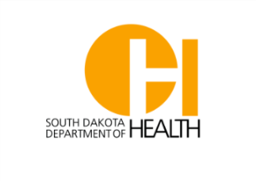
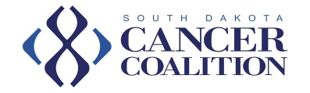

Someone You Love Documentary

The South Dakota Cancer Coalition has funds available to sponsor the screening fees for a select number of SD communities, schools, and organizations to show the Someone You Love documentary. If you are interested, please complete the form below and email it to Sarah.Quail@state.sd.us no later than June 1, 2018. Applications will be processed on a first come, first serve basis until funds are depleted.

Name:
Organization Name (if requesting on behalf of a business/school):
Email Address:

Phone Number:
Community that will host the Someone You Love documentary:
Venue for the screening:
Date of Screening:
Who is your intended audience? Select all that apply.
☐Community Members ☐Healthcare Professionals
☐College Students ☐Adolescents

☐Parents
☐Other, please describe: ___________________________________

Approximate number of attendees:
☐1-10 ☐11-20
☐21-49 ☐50-99

☐100+

Are you interested in hosting multiple screenings of the Someone You Love documentary? If so, please explain.

A panel or presentation by a healthcare professional immediately following the documentary is strongly recommended. Please describe how you will engage attendees immediately following the documentary, including names of potential panelists or presenters.

An evaluation must be completed by all individuals viewing the documentary. Do you agree to print and distribute a brief evaluation form and share all results with the SD Cancer Coalition?
☐Yes
☐No

